Middle and High School Students



Get CREATIVE and win CASH prizes!

Enter TODAY!

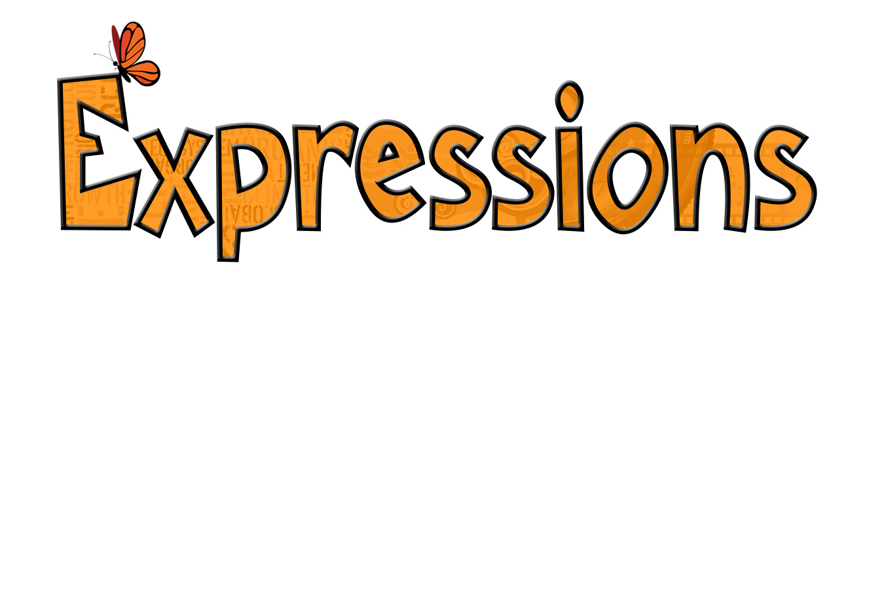

**Need Guidelines? Got Questions?** Visit <https://thelitalliance.org> Contact Christine Frascarelli ([christine@thelitalliance.org](mailto:christine@thelitalliance.org))

or Diane Keyes ([diane@thelitalliance.org](mailto:emily@thelitalliance.org)).

Type to enter text

# Entry Deadline - Friday, 11:59pm, January 24, 2020

# Awards Night - Thursday, 7:00pm, March 26, 2020

**Enter:**

**Written** - short story, poem, song, or short skit under 600 words

**Artwork -** painting, drawing, sculpture, photograph, or graphic design

**Video -** short film

Hosted by The Literacy Alliance