The Read Book
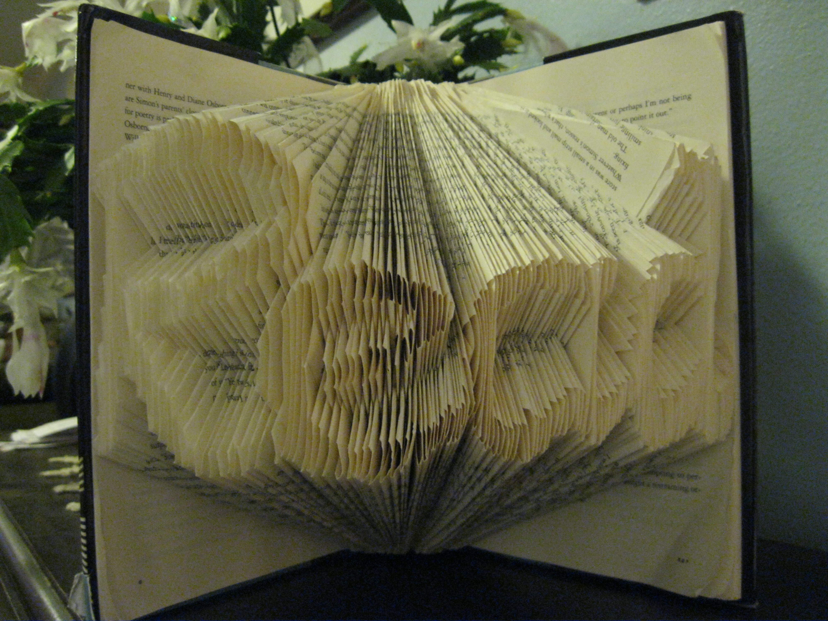

This altered book is made entirely from folded pages. There is no cutting, trimming, or pasting involved.

Step 1: Choose a book with an intact cover and reasonably clean edges, with enough pages to display the word of your choice.
TIP: Choose a book that has approximately 140 pages per letter. So, for Read, you’re going to need 560 pages or more.
Step 2: If you are good at freehand drawing, draw the OUTLINE of your word on the fore edges (this is the name for the edge of the pages opposite the spine). Center it up and down. Your word will need to be disproportionately skinny, because the letters are going to be 6-9 times as wide as you draw them.
If you are not good at freehand drawing, play with WordArt in MS Word to create a template for tracing.
TIP: Choose a font whose letters connect to each other. You don’t want to have unfolded pages between letters. Also, make sure no part of the word has more than three horizontal sections stacked together. E or E is okay, E is not.
Example -

Finally, drag the sides of your WordArt in until it is narrow enough to fit comfortably along the edges of your book, inside the covers, with some pages on either side of it (again, for an average novel, probably 1.2” or so). The Reads below are each 5” high and 1.17” wide.

Step 3: Now that you have the outline drawn on your fore edges, you can start folding. Start at the far left side. Fold the top of the page toward the left, down to the top line of your outlined word. Fold the bottom of the page to the left, up to the bottom line of that section of the outlined letter. This should leave you just the part of the fore edge that was inside your outline.
For your second page, fold the top of the page toward the left, down to the top line of the bottommost section of your word. Fold the bottom of the page to the left, up to the bottom line of that section of the outlined word

Fold 1: Fold 2:

Proceed from left to right, alternating from the top section of your word to the bottom section. When you get to a part with three (like where the bend of the R meets the upright part of the R), alternate Top, Middle, Bottom.
TIPS: Angle your folds so that they follow the contours of your letters; where the letter section is near the top of the book, your fold on the top edge should be further from the spine and where the letter section is near the bottom of the book, your fold on the top edge should be closer to the spine (and the same is true for the bottom of the book). Whenever possible, slope pure uprights on a diagonal (see the upright in the R in the very top picture); long, straight sections of fore edge will detract from the appearance.
When you get to the last letter, if it has a serif (the little flag on the top of the d, circled above), fold that section to the right instead of to the left.

